## Seth Rodriguez

4/4/2023

CS 3331 – Advanced Object-Oriented Programming – Spring 2023

## Dr. Daniel Mejia

## PA4

This work was done individually and completely on my own. I did not share, reproduce, or alter any part of this assignment for any purpose. I did not share code, upload this assignment online in any form, or view/received/modified code written from anyone else. All deliverables were produced entirely on my own. This assignment is part of an academic course at The University of Texas at El Paso and a grade will be assigned for the work I produced.

# **Program Explanation**

In PA4, I added new user interaction and customer/employee menu options to my flight booking program. The main feature added was the implementation of a dynamically read file that creates objects from provided data files by creating a HashMap with the indexes of where words are and placing them in the corresponding place within the object as well as an Automatic Ticket Purchasing Feature and another menu option to view information regarding airports. I also added functionality to purchase tickets for employees and introduced fees such as security fees, minor airline fees, and standard sales taxes. Additionally, I made the code more modular and separated the main method into different void methods within the main file to print the menu options. As a result, the code looks much cleaner and well-organized.

# **What did I learn?**

During PA4, I gained valuable experience in improving user interaction functionality, updating customer and employee role objects, and implementing features such as ticket purchasing, a new way to handle cancellation, and refunds. I also learned how to log actions to a separate file to track program actions. To improve my program further, I plan to simplify complex and lengthy code blocks into more manageable and readable sections of code. I will add more documentation throughout the program to improve its overall readability and understandability and have already started adding Javadoc throughout the program. Additionally, I will focus on adding more error handling and input validation to prevent potential issues and ensure the program runs smoothly, which again I have added but there may be some exceptions I haven’t caught. Lastly, I will conduct more rigorous testing to identify and resolve any lingering bugs. I found that using HashMaps and multiple files to form one program was helpful in organizing my code better and optimizing the usage of functions. I also learned that separating one big menu into smaller submenus helps with readability.,

# **Design**

This program simulates a flight booking system and requires students to modify or add to existing code developed since PA0. I followed the assignment guidelines to create a program that offers a seamless user experience while minimizing input exceptions. The program utilizes multiple HashMaps as the primary data structure to manage important objects from CSV files, such as tickets and objects created during customer and employee ticket purchases. I followed the assignment instructions, however I did make the assumption that employees do not hav ethe option to cancel their own tickets. The purpose of this lab report is to document improvements made to the program's functionality, specifically in the areas of customer and employee role functionalities and user interactions. These updates aimed to enhance the program's usability and effectiveness in managing flight reservations. While the program is not yet fully refined and polished, it is satisfactory and provides a good user experience.

# **Testing**

During testing, I conducted thorough testing by inputting values for various scenarios I anticipated and ensured that my program could handle them efficiently. Although I did not create standardized tests, my testing was for the most part rigorous, and I was able to verify that my program worked in most scenarios. In addition to white-box testing, I experimented with the use of test cases performed on multiple functions present within my project.

# **Test results**

I added new search functionality for customers, allowing them to search for flights by origin/destination airport codes. I also added airport functionality to employees, enabling them to inquire about airport information by airport code. Additionally, I added automatic purchasing functionality for employees using the "Autopurchase.csv" file. These new features performed as expected during my testing. I plan to continue to refine and improve my code by identifying and addressing any potential issues as they arise.

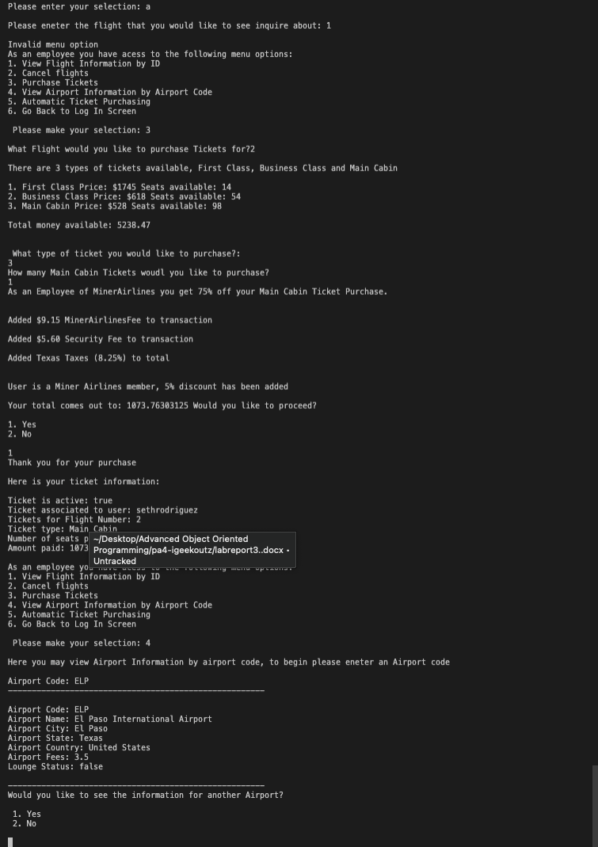

# **Code Review**

After completing my code, I carefully reviewed the instructions for PA and other provided documents to ensure that I included all necessary functionalities and made required changes. However, I acknowledge that my code may not handle all exceptions gracefully. Still, I'm confident that my skills will improve as the class progresses, and I plan to dedicate more time to studying the code to make it more robust and efficient. In addition to self-study, I intend to seek feedback from peers and instructors to identify areas for improvement. I'm excited to continue learning and improving my coding skills in this class.